LAB = 11

1. Write a Python program to sum all the items in a list.

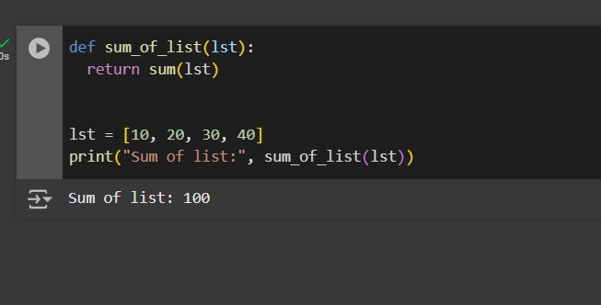

1. Write a Python program to get the largest and smallest number from a list without built-in functions.

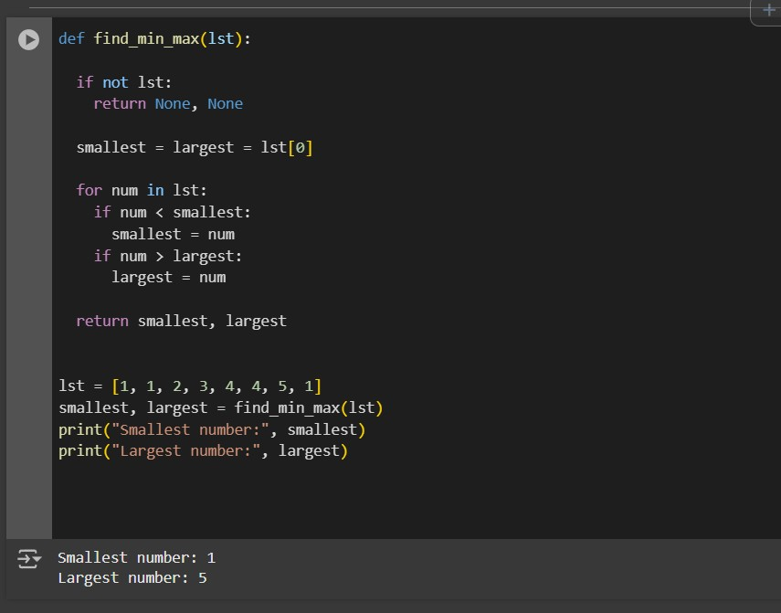

1. Write a Python program to find duplicate values from a list and display those.

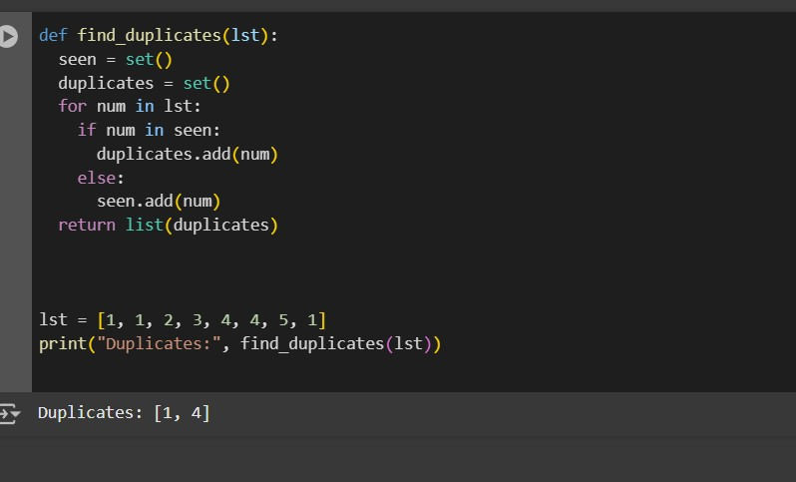

4. Write a Python program to split a given list into two parts where the length of the first part of the list is given.

Original list: [1, 1, 2, 3, 4, 4, 5, 1]

OUTPUT :

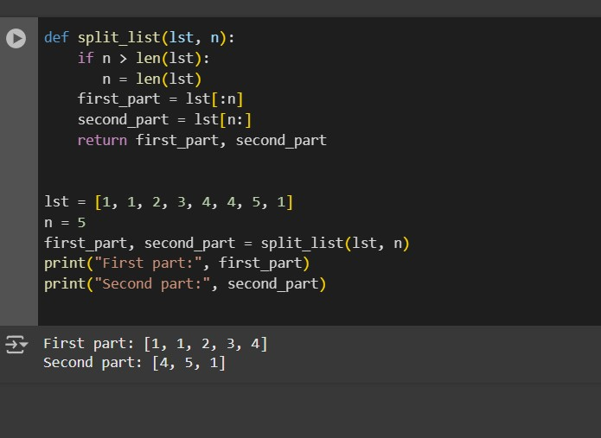

1. Write a Python program to traverse a given list in reverse order, and print the

